
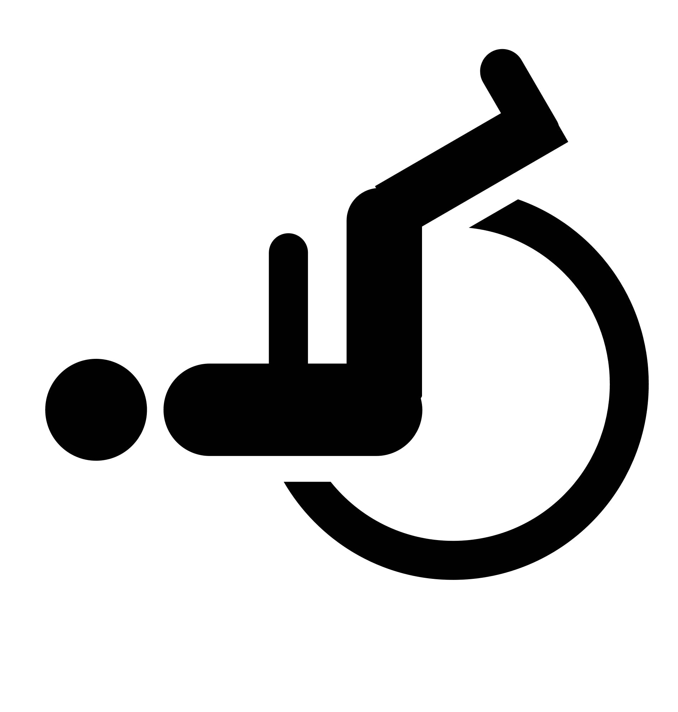

Baby Change
Cleaning store
WC

WC

WC

Church
Office

Staff Office

Hebron Kitchen

Foyer
Drop In
Youth
Children
MS Society
Bumps & Babies
Uniformed Organisations

Philippi

Lebanon

Philippi Kitchen

Male WC

Female WC
WC

Jericho

Ephesus Room

(Church use only)

Counselling 2

Church

Hebron
C1
(Church use only)


Galilee

Front Office

